- Added setting to vendor in admin panel of magento(for platform owner only)
  - Go to Sales->Vendors
  - Select required vendor and go to Vendor edit form
  - Open Preferences tab ->Two-Factor Authentication
  - Enable – yes – this vendor and VendorUsers for this vendor will have the two-factor authentication enabled. Therefore there will be two-factor auth step on vendor login action.
  - Enable – no – this vendor and VendorUsers for this vendor will have the two-factor authentication disabled. .Therefore there will not be two-factor auth step on vendor login action.
  - Click on “Save Vendor” button
  - Got to System->Cache Management and clean the cache.
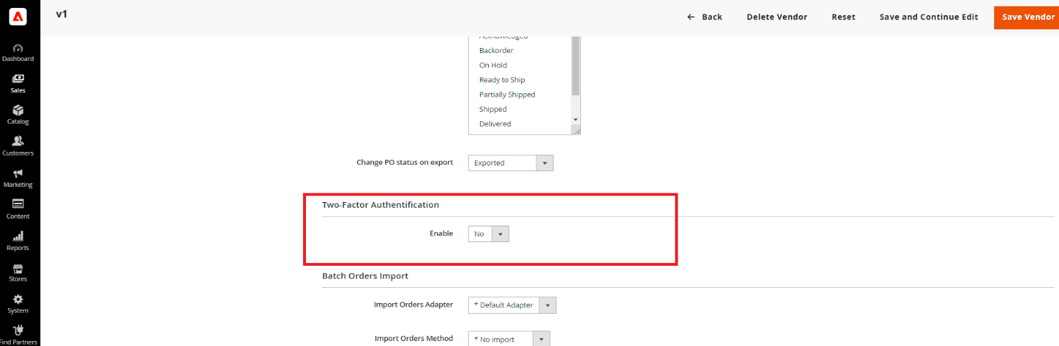
- Vendor login with Two-Factor auth enabled like described above:
  - Go to vendor portal.
  - Login via Vendor credentials
  - If Two-Factor auth have been already configured, then two-factor auth form will be shown:
  - Enter the code from Google Authenticator Application and press confirm.
  - All vendor pages should be available.
  - If Two-factor auth have not been configured then on after vendor login the message that configuration was sent to vendor or Vendor user email will be shown.
  - Vendor should go into his email provider and click on the provided link to further configure the Two-factor auth
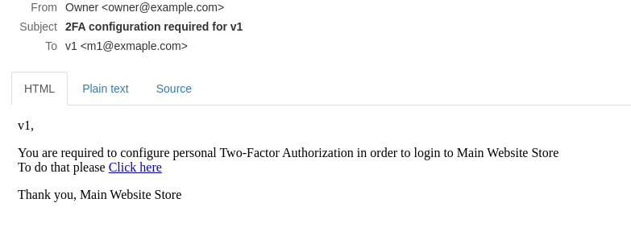
  - After page opened the google authentication page with QR code and code will be shown
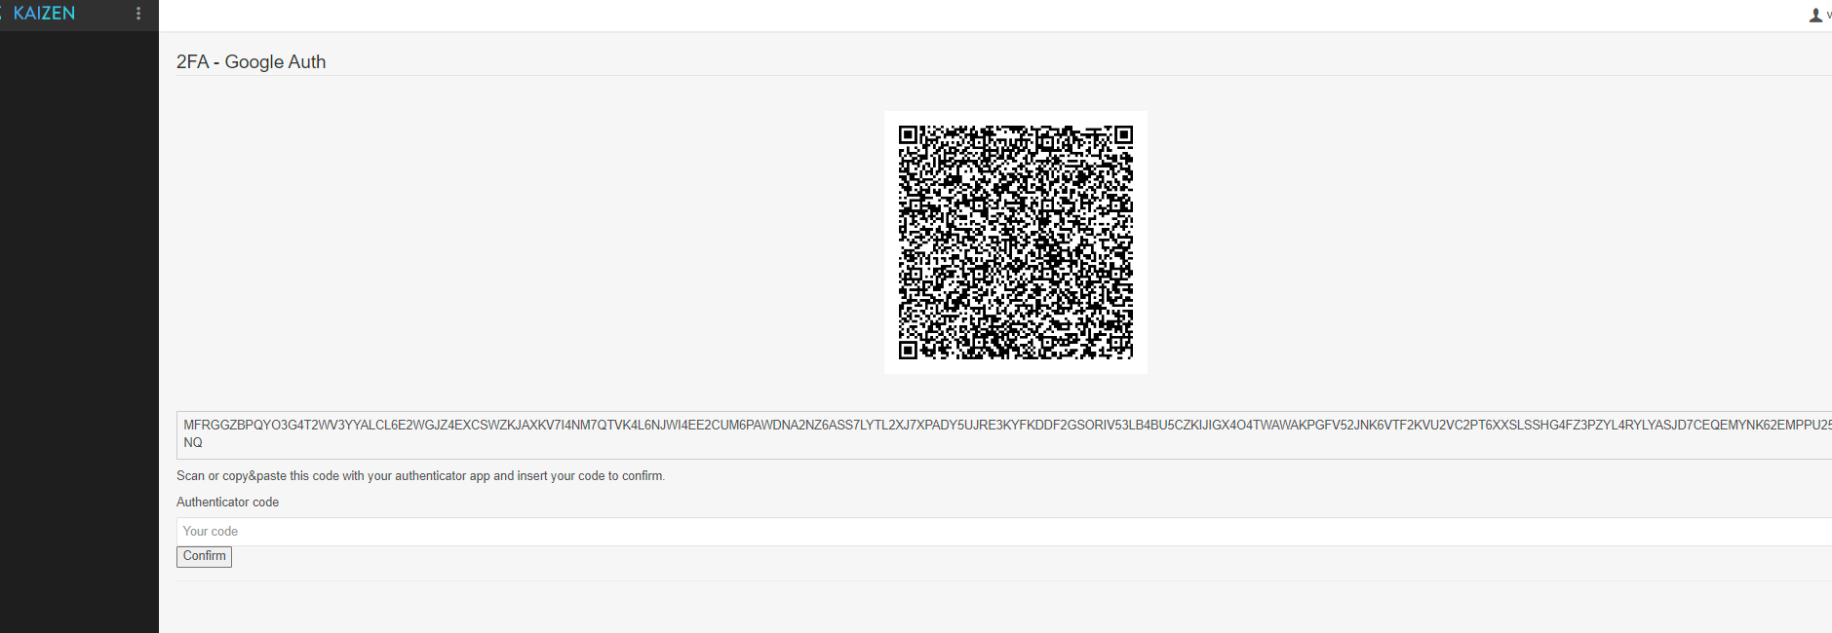
  - Scan the QR with google authenticator application and enter the code provided.
  - Press confirm
  - Vendor portal page with all menus avaible should be opened.

